**Tasks**

The visualization titled "Change of Different Encounter Type Counts with Years" is meticulously designed to accomplish a series of analytical and interpretative tasks:

**Trend Analysis:** It facilitates an in-depth examination of the yearly trends in different types of border encounters, namely Apprehensions, Expulsions, and Inadmissibles, from 2020 to 2023.

**Comparative Insight:** By presenting the counts of each encounter type as separate lines on the graph, the visualization enables viewers to compare the frequency of each encounter type directly across the given years.

**Aggregate Analysis:** The observation that the sum of all types of encounters has been increasing annually provides a macro-level insight into the growing trend of border encounters overall.

**Dynamic Observation:** Highlighting the specific trend of each encounter type—Apprehensions and Inadmissibles increasing rapidly, whereas Expulsions increase initially but then decrease—allows for a nuanced understanding of how policies or external factors might be influencing these patterns.

Viewers will gain a comprehensive understanding of how border encounter trends have evolved over the specified period, facilitating informed discussions on border security, immigration policies, and their implications.

**Data**

Same dataset as the 4th picture.

**Design process**

Originally, I decided to draw a line chart like to show the Total Encounter Counts with Years.

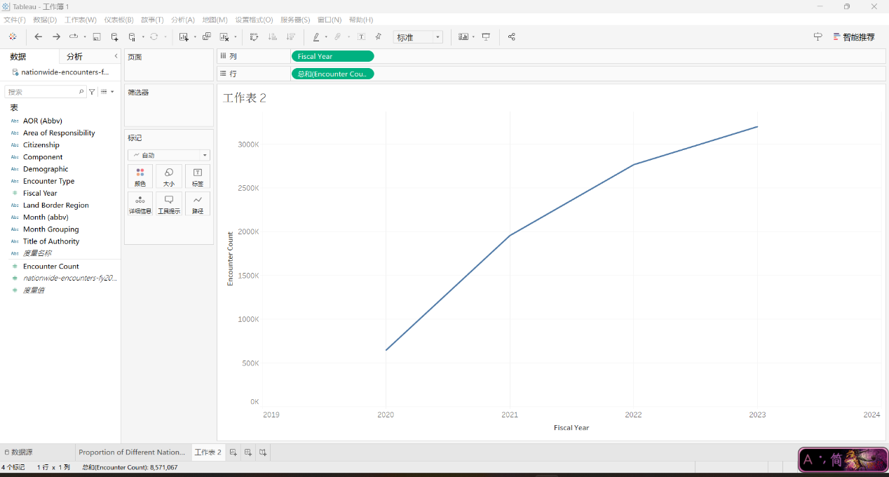

But then I found that the information it showed is too limited, which made me decided to show the details of different encounter types.

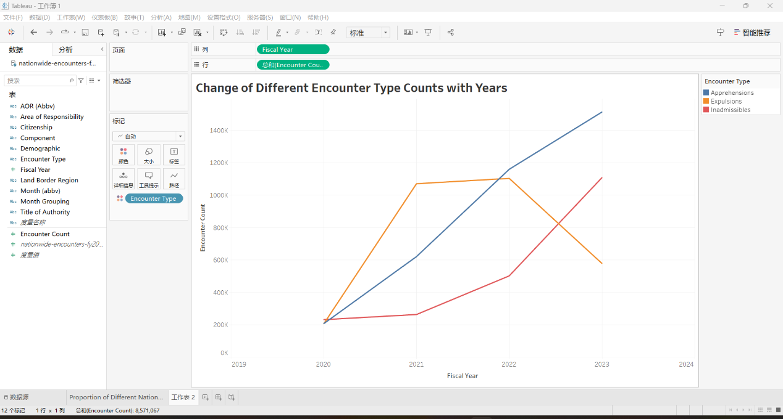

**Qualitative self-evaluation**

**Evaluation:** My design clearly visualizes the trend of border encounters over four years, effectively distinguishing between Apprehensions, Expulsions, and Inadmissibles. This approach aligns with the principle of clear data representation and comparison.

**Effectiveness:** The line chart enables viewers to easily discern trends and compare encounter types, showcasing the effectiveness of data visualization in revealing patterns and insights.

**Improvement Areas:** Incorporating interactive features could enhance user engagement, allowing for personalized data exploration. Adjustments for accessibility, such as color-blind-friendly palettes, would make the visualization more inclusive.

**Class Principles Connection:** The design reflects principles of clarity, efficiency, and accurate data representation, emphasizing the importance of thoughtful visualization in conveying complex information. Future improvements could focus on enhancing interactivity and accessibility, further aligning with best practices in data visualization.